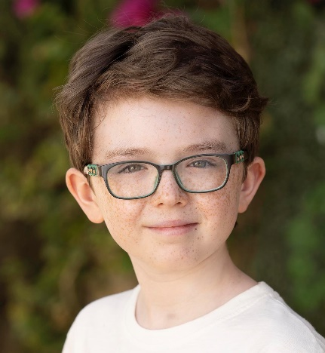 |  | BRENNAN ACTING AGENCY  Griffin Rath Hall, Maynooth, Co. Kildare, Ireland.  Phone Laura: +353894182693  Email: laurabrennanagency@gmail.com  Aidan McCann
Playing Age: 9 –13 | Hair: Dark Blonde |  |  | Height: 5 ft/ 152cms |  | Build: Slim/Petite | Eyes: Green
FILM & TV |  |  | PART |  | PRODUCTION |  | DIRECTOR
Send in the Clown (Feature Film, 2022)  Bad Sisters (TV 2021 &2022) |  |  | Nathan  David (lead child) |  | JUGGLENAUT FILMS DAC  Merman TV |  | George Kane  Dearbhla Walsh
The Holiday (TV 2021, filmed in Malta,  April - May) |  |  | Daniel (lead child) |  | Chalkboard/Projector  Pictures |  | Laura Way
Bright Sparks (TV 2021 Season 3) |  |  | Billy Meter (lead role) |  | Macalla Teo |  | Marissa Aroy
The Ellen Show (TV, Nov 2020) |  |  | Magician (via video link) |  | NBC |  | Ellen De Generes
After School Hub (TV, 2020 & 2021) |  |  | Guest Presenter |  | Macalla Teo |  | Jack Sheridan
Blue Peter (Live TV, Oct 2020) |  |  | Magician/Presenter |  | BBC |  | Martin Williams-Neale
Britain’s Got Talent Final (TV, 2020) |  |  | Finalist – Magician |  | Syco TV |  | Simon Cowell
Gamer Mode (TV, Oct 2020) |  |  | Guest Presenter/Gamer |  | Roundstone Media |  | Triona Campbell
Bright Sparks (TV 2020 Season 2) |  |  | Billy Meter (lead role) |  | Macalla Teo |  | Séamus Waters
Britain’s Got Talent (TV, 2020) |  |  | Semi-finalist – Magician |  | Syco TV |  | Simon Cowell
Aidan’s Magic Corner (TV, 2020) |  |  | Magician/Interviewer |  | The Ellen Show |  | Christopher Abbot
Little Big Shots USA with host Melissa  McCarthy (TV, Jan 2020) |  |  | Himself – Magician |  | NBC/Warner Horizon |  | Russell Norman
Lidl (Christmas Campaign 2019) |  |  | Featured Boy |  | Pull the Trigger |  | Zach Guerra
The Ellen Show (TV, Oct 2019 Live  Recording in LA) |  |  | Magician |  | NBC |  | Andy Lassner
‘Limitless' - Shin Lim, Las Vegas (Stage  Show, July 2019) |  |  | Special Guest Magician |  | Mirage Hotel |  | William Blumenreich
Center Parcs (July 2019) |  |  | Featured Voice-Over |  | Radio Campaign |  | Chemistry
Bright Sparks (TV, Season 1 & Christmas  Panto 2019) |  |  | Billy Meter |  | Macalla Teo / RTE |  | Stevie Vickers
The Ellen Show (TV, May 2019 - Live Recording LA) |  |  | Magician - Interview &  Performance |  | Ellen DeGeneres |  | Christopher Abbott
Sister This (Short Film, 2019) |  |  | Josh (Featured Boy) |  | Parallel Films |  | Claire Byrne
Credit Union (Online Campaign, 2019) |  |  | Featured Boy |  | Mirror Media |  | Caroline Christie
Ireland’s Got Talent 2019  (TV & Live semi-final show) |  |  | Magician  Top 3 Semi-finalist |  | Virgin Media/Kite  Productions |  | Various
'YOYO' (Animated TV Series 2018/19) |  |  | Leo (Lead V/O Artist) |  | Telegael |  | Various
Vodafone 'Getting to Know You'  (Campaign, 2018) |  |  | Featured Lead Boy |  | Town Productions /Grey  London |  | Marc Hatfield
Red Rock (TV Series, 2018) |  |  | Finn Bruton |  | Ridge Film Prods. |  | Hannah Quinn & Rob  Burke
Leap of Faith (Short, 2017) |  |  | Jack |  | RTE/BBC NI |  | Jonathan Farrelly

Achievements
In 2020, Aidan qualified for the grand-final of Britain’s Got Talent. He was also a semi-finalist on Ireland’s Got Talent the previous year, finishing in the Top 3 of his group. Since then, he has appeared several times on The Ellen Show in Los Angeles and is a regular host of his own segment ‘Aidan’s Magic Corner’ interviewing celebrities including Colin Farrell, Emily Blunt and The Jonas Brothers. After receiving a personal invitation, Aidan took his magic to Las Vegas with a special guest performance at Shin Lim’s Magic Stage Show “Limitless”.
Skills and Hobbies
Aidan is an experienced young actor, magician, performer, gamer, you-tuber and voice-over artist. He enjoys making and editing videos, gaming, cycling and is an advanced swimmer. He has a great ear for accents and is a natural comedian.

